Disley Parish Council
Disley Parish Council Data Protection Policy

In this policy, 'data protection legislation' means the UK General Data Protection Regulation (UK GDPR) and the Data Protection Act 2018.
The UK GDPR and Data Protection Act 2018 regulates the processing of information relating to individuals, this includes the obtaining, holding, using or disclosing of such information, and covers computerised records as well as manual filing systems and card indexes.
Disley Parish Council may need to collect and use certain types of information about individuals with whom it deals in order to carry out its day to day business and fulfil its functions and objectives. These individuals may include current, past and prospective staff and officers, members of local authorities, suppliers, clients, customers and others with whom the Council communicates.
Disley Parish Council may also hold information relating to other individuals in the course of its activities. In addition, it may be required by law to collect and use certain types of personal information.
This personal information whether held in paper form, electronically, or in any other medium, must be collected, stored and processed in accordance with the UK General Data protection Regulation (UK GDPR) and the Data Protection Act 2018 principles.

Summary of Principles
Data users must comply with the Data Protection principles of good practice which underpin the UK General Data Protection Regulation (UK GDPR) and the Data Protection Act 2018. These state that personal data shall be:
- processed lawfully, fairly and in a transparent manner.
- used only for limited, specified stated purposes and not used or disclosed in any way incompatible with those purposes.
- adequate, relevant and limited to what is necessary.
- accurate and, where necessary, up to date.
- not kept for longer than necessary; and
- kept safe and secure

Disley Parish Council regards the lawful and fair processing of personal information as very important to its effective operations, as it helps to maintain confidence between the Council and those with whom it deals. To this end, Disley Parish Council will:
1. Collect and hold only the minimum personal data necessary to carry out its functions and activities
2. Comply with the UK General Data Protection Regulation (UK GDPR) and the Data Protection Act 2018, as well as relevant codes of practice and guidance
3. Treat all personal information with respect and in accordance with individuals’ rights to privacy
4. Be open and transparent with individuals about how their personal data is collected, used and stored.
5. Provide appropriate training and guidance to staff on their data protection obligations
6. Have regard to guidance issued by the Information Commissioner’s Office (ICO) and applicable legal requirements when interpreting data protection legislation. In all cases, the Council will take account of individuals’ rights as set out in its Privacy Notice.
7. Apply the data protection principles as the foundation for information management across the organisation.
8. Only process personal data for specified, explicit, and legitimate purposes that have been notified to individuals and, where applicable, to the ICO.

Data Security
All staff are responsible for ensuring that:
- Any personal data they hold, whether in electronic or paper format, is kept securely.
- Personal information is not disclosed, whether deliberately or accidentally either orally or in writing to any unauthorised third party.
- They comply with the UK GDPR, the Data Protection Act 2018, and the Council’s data protection policies and procedures when processing or using personal data.

Staff must report any suspected or actual data breach to the Parish Clerk immediately.

In the event of a personal data breach, the Council will assess the risk to individuals and, where required, report the breach to the Information Commissioner's Office (ICO) within 72 hours of becoming aware of it, in accordance with UK GDPR.

Data Controller registration
A copy of Disley Parish Council’s Data Protection Registration Certificate under Registration Number ZA217583 can be found in Appendix A.

Making a request for your own personal data
If you wish to request information which is held by Disley Parish Council and which relates to yourself, please complete our data access form in Appendix B and email it to clerk@disleyparishcouncil.org.uk
Or write to
Clerk to Disley Parish Council
Community Centre
Off Buxton Old Road
Disley
SK12 2BB

Disley Parish Council aims to respond to requests for access to personal data without undue delay and in any event within one month of receipt of the request. Where further information is reasonably required to verify identity or clarify the request, the one-month timeframe will commence once that information has been received.

The Council may refuse to act on a request where it is manifestly unfounded or excessive, particularly where it is repetitive. Where this applies, the Council will inform the requester and explain its decision, unless it would be unlawful to do so.

Further Information
Further information about your rights under UK data protection law is available from the Information Commissioner’s Office (ICO) at: https://ico.org.uk/
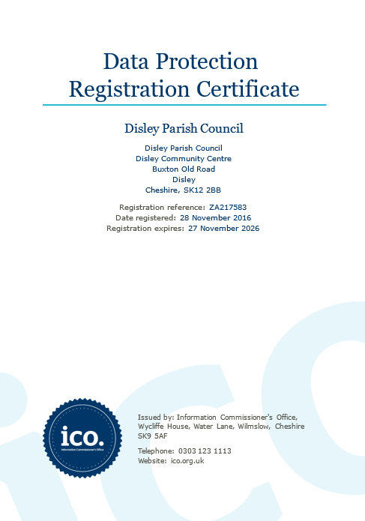
Appendix A
Appendix B
Disley Parish Council

SUBJECT ACCESS REQUEST FORM

The personal data provided on this form will be used solely for the purposes of identifying the personal data you are requesting.

You should complete this form if you want Disley Parish Council to provide you with a copy of any personal data we hold about you. You are entitled to access this information under the UK General Data Protection Regulation (UK GDPR) and the Data Protection Act 2018.

We will endeavour to respond to your request without undue delay and, in any event, within one month of receipt of your request or, where further information is reasonably required from you in order to process your request, within one month of receipt of that information.

SECTION 1
Details of the person requesting the information (Please complete)

Full name:
Address:
Postcode:
Telephone or textphone contact number:
Email address:

If this data subject request relates to you, please also tell us of any change of name, address, contact or other details which may have happened during your period of contact with Disley Parish Council to help us ensure we can identify all relevant data.

Are there any previous names or details to take into account? Yes/No

If yes, please tell us about change(s) of details below.

Previous name/s:
Previous address/es:
Previous contact details:
Telephone or textphone contact number:
Email address:

Any other relevant change(s) you want to tell us about:

SECTION 2
Does the data subject request relate to you?

Please select appropriate answer and follow to the correct section.

YES: If the data subject request relates to you, please supply evidence of your identity. This needs to be your driving licence, passport, or national identity card, together with a recent letter or bill from a utility company (within the last 3 months) as evidence of address. If you send us original documents, we will aim to return them by special delivery within 5 working days.

(Please go to Section 4)

NO: Are you acting on behalf of someone else to whom the data relates? If so, you need to have written authority – a letter from the person in question, a power of attorney document, for example - and that authority must be enclosed.

You must also supply evidence of your own identity, i.e. a driving licence, passport, national identity card, a recent letter or utility company bill (within the last 3 months) as evidence of address. If you send us original documents, we will aim to return them by special delivery within 5 working days.

(Please go to Section 3)

We cannot grant your request if we do not receive sufficient evidence of identity.

SECTION 3

Details of the data subject (the data subject is the person whose information you wish to obtain - please complete if different from Section 1)

Full name:
Address:
Postcode:
Telephone or textphone contact number:
Email address:

Please also tell us of any change of name, address, contact or other details for the data subject which may have happened during their period of contact with Disley Parish Council, to help us ensure we can identify all relevant data.

Are there any previous names or details to take into account? Yes / No

If yes, please tell us about change(s) of details below.

Previous name/s:
Previous address/es:
Previous contact details:
Telephone/textphone contact number
Email address

SECTION 4

What information are you seeking?

Please describe the personal data you seek in as much detail as possible together with any other relevant information. This will help us to identify the information you require and respond to you quickly.

SECTION 5

If applicable which of the following do you wish to receive information about?

- Why we are processing your personal data Yes/No (delete as appropriate)
- To whom your personal data is disclosed Yes/No (delete as appropriate)
- The source of your personal data Yes/No (delete as appropriate)

Please note that if the information you request includes personal data relating to another individual, we may need to consider whether disclosure would adversely affect the rights and freedoms of that individual. Where appropriate, we may redact third-party personal data or withhold certain personal data in order to comply with the UK General Data Protection Regulation (UK GDPR). In such cases, we will inform you promptly and provide full reasons for our decision, unless to do so would itself disclose exempt information.

In most cases, we will be able to provide you with copies of the personal data you request. However, in accordance with the UK General Data Protection Regulation (UK GDPR) and the Data Protection Act 2018, there are limited circumstances in which we may be unable to provide information if doing so would involve disproportionate effort. Where this applies, we will consider whether alternative forms of access, such as a summary of the personal data, can be provided. We will also inform you of the reasons why we are unable to provide the requested information, unless to do so would itself disclose exempt information.

Finally, please note that you have the right to request rectification of any inaccurate personal data we hold about you. If you believe that any personal data we hold is incorrect, please notify us as soon as possible, clearly indicating what should be corrected, the reason for the change, and, where appropriate, providing supporting evidence.
You also have the right, in certain circumstances, to request the erasure of your personal data, for example where the data is no longer necessary for the purpose for which it was collected, or where other legal grounds for deletion apply.
DECLARATION

Please note that any attempt to mislead by providing false information may result in prosecution.

I confirm that I have read and understood the terms of this subject access form and certify that the information given is true and accurate. I understand that it is necessary for Disley Parish Council to confirm my/the data subject’s identity and it may be necessary to obtain more detailed information in order to locate the correct personal data.

Signed………………………………………….. Date ……………..

Print Name..............................................................................................

Documents which must accompany this application:

- Evidence of your identity (Section 2)
- Evidence of the data subject’s identity (if different from above)
- Authorisation from the data subject to act on their behalf (if applicable)

If, when you have received the requested information, you believe that:

- the information is inaccurate or out of date; or
- we should no longer be holding that information; or
- we are using your information for a purpose of which you were unaware; or
- we may have passed inaccurate information about you to someone else

you should notify us at once at the address below.

Please return the completed form and identification to:

by email: clerk@disleyparishcouncil.org.uk

Or by post: Clerk to Disley Parish Council
Community Centre
Off Buxton Old Road
Disley
SK12 2BB

