
DISLEY PARISH COUNCIL
Sarah Allen
_{Disley Parish Clerk}
Tel: 01663 7627262
Email: admin@disleyparishcouncil.org.uk
Web: www.disleyparishcouncil.org.uk
Councillors are summoned to the Council Meeting to be held on 11th June 2026 at 7pm at
Disley Community Centre, SK12 2BB
This meeting will be recorded for ease of minute production.
Signed:  Sarah Allen (Parish Clerk)
Dated: 5th June 2026
- To receive and approve any Apologies for Absence.
- To receive any declarations of Disclosable Pecuniary Interests (DPI), Person Interests or Prejudicial Interests as defined in the Member Code of Conduct.
- To approve as a correct record the minutes of the Parish Council meeting held on 14th May 2026.
- To receive comments from members of the public in accordance with guidance provided on the website: Public-Participation-at-Council-Meetings-11-02-2015.pdf.
- To consider an application for co-option to the Parish Council from a resident who satisfies the eligibility requirements of section 79 of the Local Government Act 1972 and is not disqualified under section 80 of the Act and, where no by-election has been called pursuant to Section 87(2), to resolve whether to appoint the applicant and agree any consequential actions.
- To receive a verbal report from the Chair.
- To receive Cheshire East Councillor’s Report.
- To consider arrangements and content for the Parish Council stand at Disley Show, including agreeing a rota of Councillors between 12pm and 5pm.
- To retrospectively approve the payment approval lists 15th May and 3rd June 2026 that were signed by two councillors prior to payment.
- To consider the email from a member of public in regard to Pickleball courts.
- To consider suitable locations for a mobile Household Waste Recycling Centre (HWRC).
- To consider the email from Disley Local History Society (DLHS) in regards to a bench in memory of a founder DLHS member.
- To note that the free emergency planning training sessions discussed at last month’s council meeting are more suited to local organisations. Disley Parish Council will therefore make this information available to local groups.
- To note the statement from Cllr Brinnand.
- To note the response to enquiries submitted to Tim Roca from David Parkin.
- To note the email from Tim Roca.
- Planning
Reference | Address | Details | COMMENTS
26/1810/VOC | The Homestead,  Homestead Road,  Disley SK12 2JP | Variation of condition 3 on approval 25/0559/HOUS: Demolition of existing outbuilding and construction of an underground swimming pool and games room with hillside terrace. | Deadline 16/06/26
26/0974/FUL | Disley Meadow,  Lower Greenshall  Lane, Disley, SK12  2HH | Appeal against the refusal of planning permission for retrospective planning permission for the retention of a small number of agricultural structures and associated areas of hardstanding. The holding is used for keeping and managing alpacas, which require daily husbandry, feeding, and welfare monitoring. The works comprise a storage container, two small timber shelters, and limited stone hardstanding. The holding contains no existing farm buildings or residential property, so these structures provide essential infrastructure to allow the holding to operate safely and effectively. | Deadline 07/07/26
DECISIONS
25/0321/FUL | Former Council  Depot, Buxton Road  West, Disley | The erection of a single dwelling with landscape improvements on the former council depot site in  Disley. | Granted subject to 20 conditions
25/3609/HOUS | 18 Jacksons Edge  Road, Disley SK12  2JE | Retrospective planning for 6 foot fence adjacent to highway. At least 1 car width from the highway as the pavement is extremely wide (see images). No views are restricted and | Refused - the proposed fence by virtue of its height, scale, use of materials and prominence
 |  | does not affect neighbouring boundaries. Allows some form of privacy as it is essentially the back garden. Thus, allowing children and dogs to play ball games without potential damage/accidents to the public. | represents an incongruous addition to Jacksons Edge Road to the detriment of the street scene, the character of the area and the significance of the Disley Conservation Area.
25/4899/HOUS | 36 Heysbank Road,  Disley SK12 2DF | Proposed first floor side extension, front and rear single storey extensions, new windows and flue. | Granted subject to 3 conditions
26/0391/HOUS | Dane Bank Cottages,  73 Buxton Old Road,  Disley SK12 2DQ | Two storey rear extension and single storey rear extension to extend existing single storey. | Granted subject to 3 conditions
26/0795/PRIOR-  3MA | 15 Buxton Road,  Disley SK122DZ | Prior approval change of use from Shop (Class E) to a Single Dwelling House (Class C3). | Prior approval not required.
26/0974/FUL | Disley Meadow  Lower Greenshall  Lane, Disley, SK12  2HH | Retrospective planning permission for the retention of a small number of agricultural structures and associated areas of hardstanding. The holding is used for keeping and managing alpacas, which require daily husbandry, feeding, and welfare monitoring. The works comprise a storage container, two small timber shelters, and limited stone hardstanding. The holding contains no existing farm buildings or residential property, so these structures provide essential infrastructure to allow the holding to operate safely and effectively. | Refused
26/1163/HOUS | 26 Lyme Road, Disley, SK12 2LL | Part single storey front extension. | Granted subject to 3 conditions

PART2
- Exclusion of Press & Public
To resolve that in accordance with section 1(2) of the Public Bodies (Admissions to Meetings) Act 1960, and as extended by Schedule 12A of the Local Government Act 1972, the public, including the press, be excluded from the meeting because of the confidential nature of the following business to be transacted^{i}
- To consider and approve commercially sensitive information.


DISLEYPARISHCOUNCIL
3
Disley Parish Council Annual Council Meeting Minutes
14th May 2026 at 7pm at Disley Community Centre, SK12 2BB
Present
Cllrs: Adams, Windsor, Bull, Scale, Brinnand, Johnson.
Officer in attendance
S. Allen
1 Member of the Public
- It was RESOLVED that Cllr Windsor be elected Chair of Disley Parish Council for the year 2026/2027
- Cllr Windsor signed the Declaration of Acceptance of Office and took the Chair.
- It was RESOLVED that Cllr Pattison be elected Vice Chair of Disley Parish Council for the year 2026/2027
- In the absence of Cllr Pattison, the Declaration of Acceptance of Office will be signed at a later date before the Proper Officer.
- Apologies were received from Cllr Pattison.
- In the interests of transparency, Cllr Adams declared an interest in relation to Planning Application
26/0974/FUL, having previously submitted a Call In request for the application to be referred to the Planning Committee for determination by the council. The request was not accepted. Cllr Adams confirmed that she is not a member of the determining authority in respect of the application.
- The minutes of the meeting held on 9th April 2026 were APPROVED and SIGNED as a correct record.
- The member of the public was invited to speak regarding planning applications 26/0974/FUL, Disley Meadow. The Chair proposed that agenda Item 29 – Planning, was brought forward as the next item of business in order to accommodate this.
A detailed discussion took place concerning a retrospective planning application in relation to 26/0974/FUL,Disley Meadow, involving buildings, hardstanding, and a shipping container.
Key points raised included:
- Concerns regarding drainage arrangements, with comments that the drainage appeared insufficient and not professionally carried out.
- Potential issues relating to Green Belt policy and whether the development conflicted with planning policy.
- Discussion regarding highway safety and access onto a busy road.  Members encouraged residents to:
    - Review the relevant local and neighbourhood planning policies. o Quote specific policy numbers where possible.
    - Submit concise and relevant planning comments.
- Residents were encouraged to submit planning comments directly to Cheshire East via email or the Cheshire East planning portal.
It was agreed that a draft comment on behalf of Disley Parish Council in relation to the Disley Meadow application would be prepared over the weekend and circulated to all council members for approval prior to submission by the deadline on Monday 18th May 2026.
Members then discussed the remaining planning applications.
Reference | Address | Details | COMMENTS
26/0974/FUL | Disley Meadow  Lower  Greenshall Lane,  Disley, SK12 2HH | Retrospective planning permission for the retention of a small number of agricultural structures and associated areas of hardstanding. The holding is used for keeping and managing alpacas, which require daily husbandry, feeding, and welfare monitoring. The works comprise a storage container, two small timber shelters, and limited stone hardstanding. The holding contains no existing farm buildings or residential property, so these structures provide essential infrastructure to allow the holding to operate safely and effectively. | Deadline 17/04/26 – extension sought to  18/5/26
26/0997/HOUS | 174 Buxton  Road,  Disley, SK12 1RQ | Single storey side and rear extension to create garage and additional kitchen space. | Deadline 22/04/26 – extension sought to 18/5/26  No objection.
26/1163/HOUS | 26 Lyme Road,  Disley,  SK12 2LL | Part single storey front extension | Deadline 11/05/26 – extension sought to  18/5/26  No objection.
26/1312/HOUS | 1 Chantry Road,  Disley,  SK12 2BE | New Front Porch and  Alterations to Windows | Deadline 08/05/26 – extension sought to  18/5/26
 |  |  | No objection.
26/1558/PIP | Land Off Strines  Road,  Strines, SK6 7GN | Stage 1 Permission in  Principle for single dwelling | Deadline 13/05/26 – extension sought to  18/5/26  No comment.
26/1097/LBC | 20 Jacksons Edge  Road, Disley,  SK12 2JE | Listed Building Consent for replacement of the wooden guttering at the front and rear of the property | Deadline 19/05/26 No objection.
DECISIONS
25/4356/HOUS | Old Lady House,  68  Jacksons Edge  Road,  Disley SK12 2JR | Retrospective application for retention of boundary fencing, sliding access gate and raising height of stone pillars - appeal against refusal of planning permission. | Appeal against refused application dismissed.
- The Chair gave a verbal report, noting several upcoming community events:
- Disley Proms at St Mary’s Church on Saturday, 16th May.
- Community Bus coffee morning on 30th May.
- St Mary’s Scarecrow Festival and Fete on 27th June, with a 1940s theme and invitations extended to local groups.
- A Bank Holiday weekend event being organised by a Malt Disley, including music and entertainment was also mentioned.
- Members formally APPROVED the Chair’s annual allowance for 2026-27 of £750. The Chair abstained from voting.
- Members CONSIDERED and APPROVED the councillor membership of parish council committees, representation on outside bodies, and authorised cheque signatories for the 2026–27 year.
- Members CONSIDERED and APPROVED the councillor membership of parish council project teams 2026-27 year.
- The remits of the following Standing Committees for 2026/2027 were CONFIRMED.
- Finance Committee
- Planning Committee
- Personnel Committee

- After discussion, the Annual Risk Assessment for 2026/2027 was APPROVED. Council noted concerns regarding the clarity and effectiveness of the document, including that the RAG rating system appeared inconsistent, with certain risks showing more than one rating colour. It was agreed that the format and content be revised in time for the next review.

- Following discussion, the internal year end audit report from JDH Business Services Ltd was APPROVED.
  - correction was NOTED to the agenda wording, confirming that the relevant financial year was 202526 rather than the stated 2026-27. The Clerk explained that the report formed part of the Annual Governance and Accountability Return (AGAR) process and required approval before submission. Members were advised that a further internal audit would take place in October. It was NOTED that the audit had identified areas where information had not previously been published on the website in accordance with requirements. The Clerk confirmed that the required information had now been published and that the outstanding actions identified by the auditor had largely been completed. However, as the audit related retrospectively to the previous year, the findings remained within the report.
Cllr Adams left the meeting at 7:59pm.
- The Annual Governance Statement (Section 1) of the Annual Return for the financial year 2025–2026 was APPROVED. A correction was NOTED to the agenda wording, confirming that the relevant financial year was 2025-2026 rather than the stated 2026-2027 for items 16 to 18.
- The Accounting Statements (Section 2) of the Annual Return for the financial year 2025–2026 was APPROVED.
- The following year end financial statements for the 2025/2026 year were RECEIVED and APPROVED.
- Balance sheet
- Income and Expenditure Account
- Bank reconciliations.
- The Cheshire East Councillors report was RECEIVED.
- It was NOTED the first Communications Group meeting took place on the 7th May 2026 and that notes from the meeting would follow. It was discussed that the website project would take priority and a communications strategy would follow.
- The Health & Wellbeing notes dated 9th April 2026 were NOTED.
- PC Kelly’s request to host a joint police surgery alongside Community Centre coffee mornings was CONSIDERED. Councillors welcomed the proposal and agreed that it could provide a useful opportunity for residents to speak with the police informally and raise any concerns they may have. It was agreed that the relevant community groups using the Community Centre would be informed in advance.
- Councillors considered a free emergency planning training session for councillors and staff. It was agreed that the training appeared to be beneficial, although further information was requested before a decision could be made. The item was therefore DEFERRED to the next meeting.
- Disley Parish Council CONSIDERED and RESOLVED to adopt the SLCC model Document Retention and Disposal Policy. It was NOTED that the policy applies to both digital and paper records.
- Disley Parish Council CONSIDERED and RESOLVED to adopt the updated Social Media Policy.
- Disley Parish Council CONSIDERED and RESOLVED to adopt the updated General Data Protection Regulation (GDPR) Policy.
- Councillors discussed arrangements for the upcoming Community Bus coffee morning on Saturday 30th May 2026. Cllr Brinnand and Cllr Johnson confirmed their availability to assist.
- a) Councillors NOTED that the payment lists dated 5th May 2026, 16th April 2026 and 9th April 2026 had been checked and signed by two councillors and therefore they were retrospectively APPROVED. b) Cllr Windsor checked and signed the April bank reconciliation.
- This item was considered earlier in the meeting under Item 8.

Part 2 - Exclusion of Press & Public
RESOLVED; It was unanimously agreed in accordance with the relevant legislation to exclude members of the press and public from items in Part 2, due to the confidential nature of the business to be conducted.
- Disley Parish Council CONSIDERED and AGREED staffing matters.
- Disley Parish Council CONSIDERED and AGREED commercially sensitive information.
- Meeting closed at 8:52pm.

7.
Cheshire East Councillor Report May 2026 for Disley Parish Council
Summary of Issues Raised by Residents 1-31 May 2026
Bin Collections | 1
Planning | 3
Highways | 8
Disley Meadow | 2
Housing | 1
Council Tax | 1
Other | 5
Total | 21
This month I am again providing updates on several highways projects.

Buxton Road West
Thank you to residents for their patience and understanding during the works on Buxton Road West.
Unfortunately, there are issues with the work that has been done. Temperatures reached 31 degrees in Disley and there are issues with the surface dressing. Sometimes things do go wrong, and I have been in contact with Cheshire East Highways about what needs to be done to deal with the problems. I have been assured that all issues that I have raised are being followed up. The construction team have been asked to advise dates as soon as they can. This will need to be fitted in around other programmed work, but the road will not be left as it is.
I shall be monitoring the situation closely.

Buxton Old Road
Thank you to Cllr Jean Windsor and Cllr Paul Bull for their assistance with identifying the remaining blocked gullies. We walked from the A6 to the Derbyshire border checking gullies and identifying other issues such as fly tipping (already cleared by Cheshire East), potholes, overgrown shrubbery etc. Some items have been logged on traCE for Cheshire East to deal with, and others will be dealt with by Disley Parish Council rangers where appropriate.
I have forwarded a spreadsheet with details of blocked gullies to the Cheshire East drainage team, and the gulley cleaner is due to return to Disley shortly.

Hollinwood Road
The next stage in resolving drainage issues on Hollinwood Road will involve a dig-up at the Hollinwood Road junction with Sherbrooke Road to investigate a suspected blockage. The work is provisionally planned for week commencing 22nd June.

B5470 Whaley Bridge to Macclesfield Road
The road finally re-opened on Friday 29th May.
It would be helpful if residents could continue to report blocked gullies, potholes and any other highways issues on traCE. This is the replacement for Fix My Street in Cheshire East. I review a weekly report of all items logged on traCE for Disley ward.
There is a lot more work needed to bring roads in Disley and Newtown up to an acceptable standard, and I shall continue to pursue this work on behalf of residents.

Disley Meadow
The retrospective planning application 26/0974/FUL has been refused. An appeal has been made to the Secretary of State and will be dealt with by the Planning Inspectorate.
Sue Adams
3rd June 2026.
UNCLASSIFIED

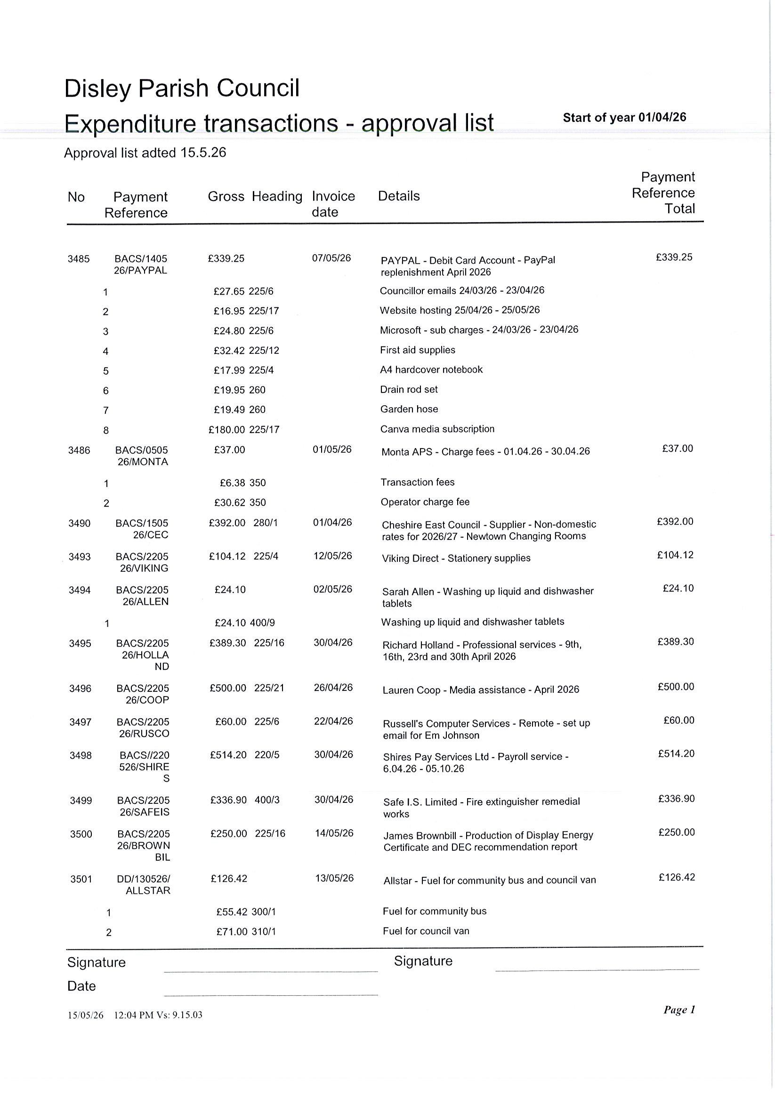
9.
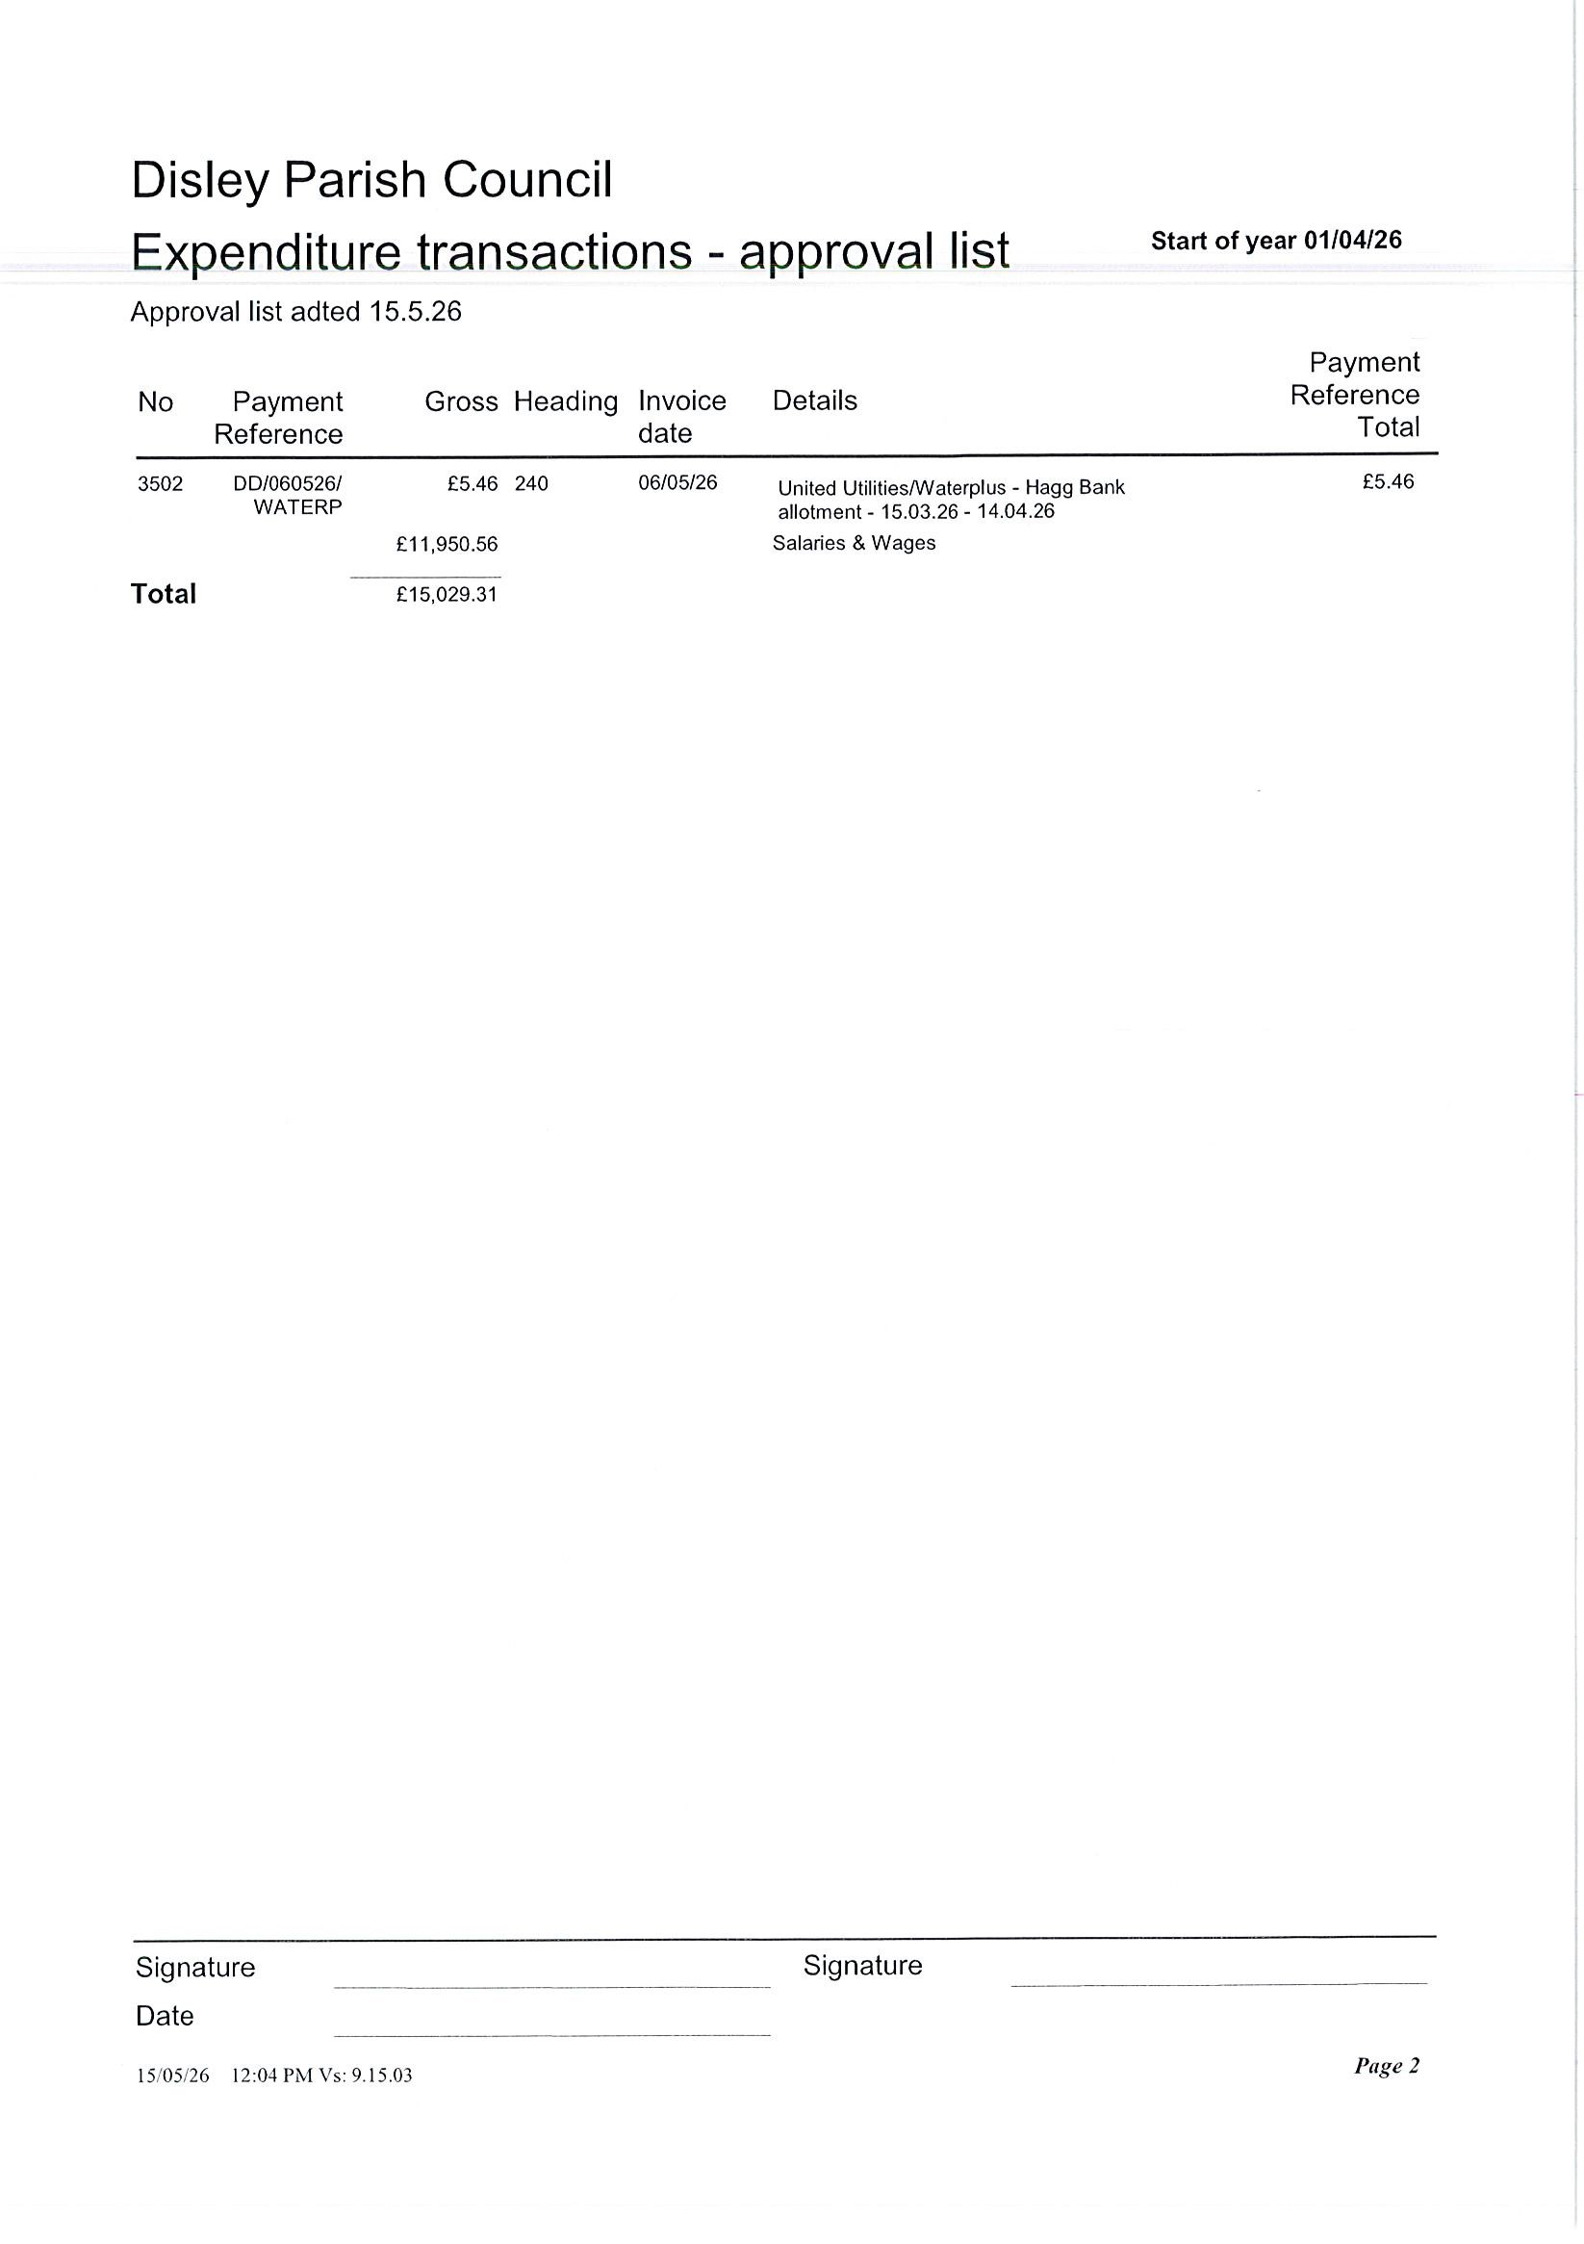
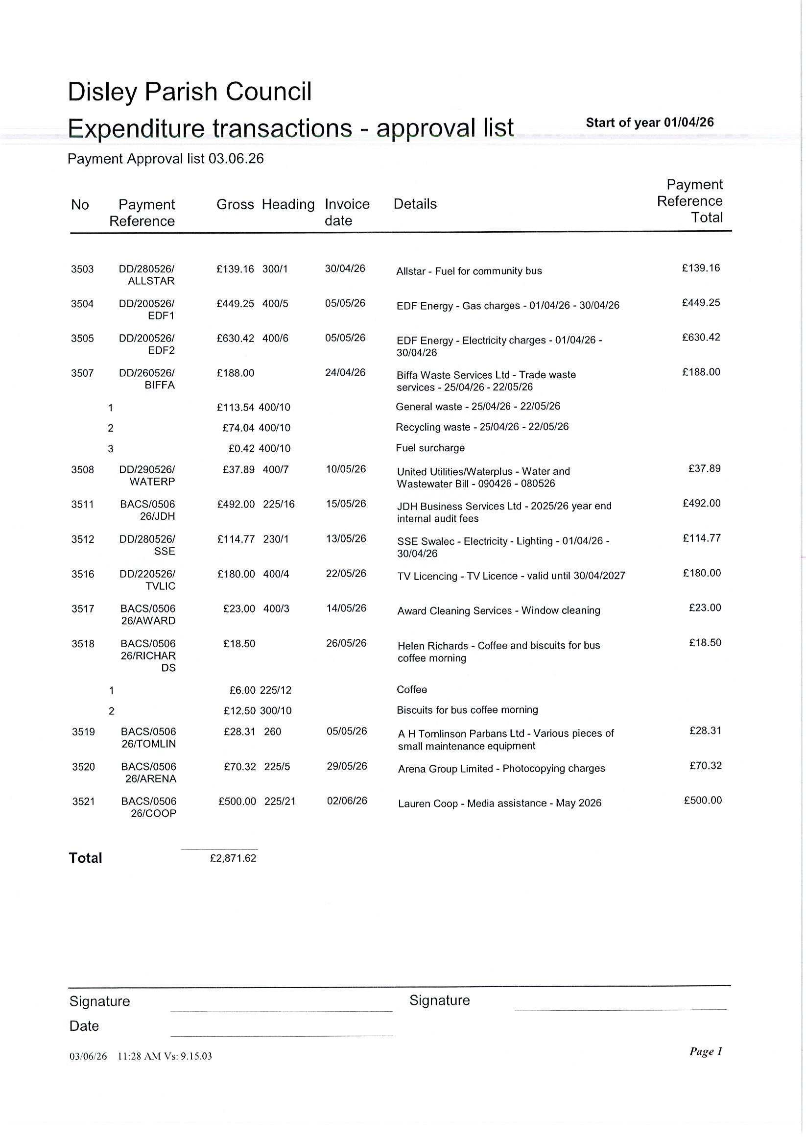
9.

I was wondering if there is any possibility to create one or two outside pickleball courts in the village.
I know on Arnold Rhodes park there’s a tennis court but it would be good to have a pickleball court too.
Pickleball is very popular and having an accessible court in the village would be great.
Perhaps this is something that could be done by contractors under social added value?
If it could be raised at the next council meeting in the village and explored if it’s something others would want or benefit from that would be interesting.
We are looking for suggestions for a suitable location for a mobile HWRC in Disley.
The Mobile HWRC service is intended to operate as follows:
- Exclusively on Saturdays.
- 6 location rotation
- Each Saturday will include two separate service stops: -Morning Stop (AM): One location will host the Mobile HWRC for the first session. Afternoon Stop (PM): The Mobile HWRC will then relocate to a separate location for the second session.
- Operating times would be : Summer (April to September) 2 x 4-hour sessions each Saturday. During the winter (October to March) the Mobile HWRC service will operate 2 x 3-hour sessions each Saturday.
If you let me have any suitable suggestions I can follow up with CEC on my return from holiday.
Kind regards,
Sue
Cllr Sue Adams
Disley Ward
Cheshire East Council
Sue.Adams@cheshireeast.gov.uk

Dear Councillors,
Thankyou for all your hard work through the years to make Disley a wonderful place to be.

We sadly lost Mr. Christopher Makepeace last year. He was a founder member of the Disley Local History Society.

To those past members we owe a great debt, as they researched, correlated and acquired many items relating to Disley and surrounding area. As an active and ongoing society we wish to acknowledge this debt.

One suggestion was to donate a bench to community centre- to join the other 2 benches and/ or a picnic table at the front area of centre.
Is this something the Parish Council would approve or help towards?.
Just a thought,
Thankyou for your time, Mrs. B.L. Roberts.
( Chairman of Disley Local History Society).

14.
Cllr Brinnand meeting with Tim Roca MP , Friday 8th May 2026
Beginning of May I received an email from Tim Roca MP inviting me to meet him at his constituency office to bring him up to date with my continuing work on Disley Post Office and to see how I’m settling into my new role as Disley Parish Councillor.
This also gave me the opportunity to discuss, and bring to his attention, the issues and concerns raised by our residents most recently.
At the meeting we discussed:
- Pedestrian Road Safety - Concerns raised regarding heavy traffic, HGV’s and traffic light jumping, raising serious safety issues, particularly for pedestrians and car users at crossings at the main fountain Square cross roads and crossing at the co-op.
- HGV use of Buxton Old road - The increasing number of overweight and oversized HGV’s using BOR causing safety concerns on this very busy route used by our parents and school children as they walk to Disley Primary School , the impact on residents and other road users.
- Peak Cluster - I expressed my concerns and those of our residents and community regarding the long term impact of Peak Cluster, the lack of transparency, the poor communication and the process. I also informed him of the update we received from Kellie Scott, General Manager at our Annual Parish Council meeting on 14th April, regarding Lyme Park in particular, and the National Trust lands also affected along the whole Peak Cluster intended route.
- Disley Post Office – Tim has been involved in this since he became our MP and before I became a Parish Councillor. I was pleased to update him on the new contact we have, who is dealing with the recruitment of our new Postmaster, the ongoing recruitment and number of applications received , together with the regular contact I still have with the Post Office and the landlord of the Disley Post Office property.
I also brought him up to date with the work we are doing across Disley & Newtown and hoped he would be available soon to come to Disley , meet our new Parish Council Clerk, Sarah Allen and the wonderful team who work for our residents and my fellow Parish Councillors.
A thank you to residents.
At our meeting in March we asked residents to collect and send evidence of the issues you have as this helps us a lot and strengthens our voice as a community. Thank you to everyone who has emailed photos and sent videos which I have passed on to Tim Roca MP and is collated by Sarah Allen our Parish Clerk.
I have provided the email correspondence received following our meeting and the attachment, received regarding his communication with Peak Cluster.
Cllr Mel Brinnand

15.

14th April 2026
Response to enquiries submitted to Tim Roca MP
Dear Tim,
Thank you for getting in touch and raising your constituents' concerns with us.
We are early in the development of the project and alongside carrying out studies and assessments, our approach has been to speak to communities at the earliest possible stage to gain local knowledge from those who know their area the best. By undertaking engagement and consultation ahead of finalising the design we are enabling local communities and stakeholders genuine agency to influence.
However, this means that we do not yet have answers to every question or detailed plans that we can use to evidence the responses we are providing. This, as you identified, results in some residents looking elsewhere for information to fill the gaps. It also means that, as a host MP, your office is receiving a great deal of correspondence about the project, and we hope this response will help address some of the main concerns your constituents have raised.
Now that the first phase of consultation has ended, we are in the process of reviewing and considering the feedback provided by local communities and stakeholders to evolve the project design. The feedback we have received thus far has been invaluable, bringing things to our attention that we otherwise wouldn’t have been aware of, demonstrating that this approach is effective.
Over the coming months, we’ll use the feedback we’ve heard during the phase 1 consultation, alongside further engineering and environmental studies, to continue to build our proposals for the project. We’ll hold a more detailed phase 2 consultation later in the year, at which point we’ll have more specific information on our plans to share.
Between now and the phase 2 consultation our communication channels will remain open, and we will be providing regular updates on our progress. At the time of writing, over 3,000 people have signed up for our newsletter on our consultation hub, and we are continually working to expand the reach of our communications.
We have compiled a series of answers to the questions your constituents have raised below.
Best regards,

David Parkin
Chair of Peak Cluster

***

Project Safety
Can you share details of the risk assessment?
Our engineering design meets recognised standards and regulations, established best practice and proven design methods and robust control safety measures to ensure risks are minimised to levels required by the Health and Safety Executive (HSE) and the Environment Agency.
As is the case with high-pressure natural gas pipelines, the Peak Cluster CO₂ pipelines are being designed to BS PD8010 standards. These standards ensure our pipeline design considers an extensive list of risk factors, including corrosion, third-party damage, proximity to communities, flooding, ground movement and so on.
We’re also implementing industry-leading leak detection technologies along the pipeline. This would likely be a Distributed Fibre Optic Sensor (DFOS) system or similar, which would run the full length of the pipeline.
The Environment Agency and the Health and Safety Executive, as prescribed consultees, are also being consulted throughout the project.
The detailed risk assessment and safety case will be developed as project engineering progresses.

What is the likelihood of leaks occurring from the pipeline and what hazards do leaks cause?
The UK has a wealth of experience in designing, constructing and operating pipelines to transport gas. The practice is very well-established and robustly regulates technology, for which the UK has earned a global reputation for safety.
The Intergovernmental Panel on Climate Change (the international authority on all matters related to climate change and low-carbon technologies) estimates that just 0.00001% of carbon dioxide transported through the pipeline would be lost through accidental leaks.
The UKOPA Product Loss Report provides a comprehensive and independent dataset of leaks from UK Major Accident Hazard Pipelines. The latest version covers the period from 1962 -2023 and documents that leaks of any size on UK Major Accident Hazard Pipelines are rare. The report states that between 1962 and 2023, across the full UK network of 27,000km there is approximately one leak per year and that more than 75% of leaks on major accident hazard pipelines are small, or pinhole in size. If a leak of this size was to occur on a CO₂ pipeline, the CO₂ gas released would be quickly dispersed.
The report states that large leaks on steel major accident hazard pipelines are typically caused from damage by third-parties or by significant land movement. The use of thickwalled steel pipe, like that which would be used for Peak Cluster’s pipeline, is very effective at preventing large leaks from these external factors.

Are you aware of a pipeline leak in Mississippi, USA, and how is Peak Cluster different from this project?
Our team is aware of the leak on the pipeline near Sartartia which was operated by Denbury Gulf Coast Pipelines. Whilst this incident is an opportunity to learn, the regulatory context for pipelines in the USA is so different to the UK, so a direct comparison is misleading.
UK regulation places people and property central to the safety assessment of a pipeline. As a result, the Peak Cluster pipeline is being built to a different standard than the pipeline near Sartartia, which would significantly reduce the leakage risk:
- The Peak Cluster pipeline will operate in gas phase at between half and a quarter of the pressure of the Denbury liquid (dense) phase pipelines.
- The Peak Cluster pipeline will have a wall thickness up to twice that of the Denbury pipeline.
- The Peak Cluster pipeline will feature stronger leak detection and improved response plans than was the case at Sartartia.

Is there a threat to life if there is a leak?
Where pipelines are properly designed, built, operated and maintained they are a safe and reliable means of transporting gases over significant distances. Gas and liquid have been transported in the UK by pipeline for more than one hundred years and there are around 27,000km of major accident hazard pipelines in the country. Peak Cluster is being designed to comply with the UK's robust Pipelines Safety Regulations (PSR) 1996, which require that the design, construction, operation and maintenance of pipelines must comply with recognised codes and standards. The UK standards for pipelines to transport CO₂ are recognised as being the most thorough in the world, and the design and operation of pipelines is regularly scrutinised by the HSE.
For an individual to be affected by carbon dioxide they must be exposed to a high concentration of gas for a period. There are many layers of protection both in the design and operation of the pipeline. High concentrations generally require a large leak which would typically be the result of external impact. Thick-walled pipe is very effective at reducing the effect of pipeline damage and UKOPA have recorded no leaks caused by external impact on thick-walled major accident hazard pipeline.

How will Peak Cluster be held accountable if any leaks or other safety defects occur?
There is a clear regulatory framework within which the pipeline and capture facilities will be designed, maintained and operated: • The Peak Cluster pipeline will be regulated by the HSE.
• The capture plants and operators will be regulated by both the HSE and the Environment Agency.
Failure to adhere to these regulations can result in improvement notices, legal consequences, fines or criminal charges for the most severe negligence or accidents.

Is there a mandatory distance separating the pipeline or AGIs from the community? A key strength of UK gas safety regulation is its goalsetting approach, rather than a narrow focus on compliance. The Pipelines Safety Regulations (1996) require operators
to design and operate their pipelines in a way that is as safe as is reasonably practicable. This means that designers and operators must deploy reasonable best practice and it allows flexibility to achieve and demonstrate safe operation. In the UK, there is no mandatory distance separating the pipeline or AGIs from the community. Instead, there is a requirement to demonstrate to the satisfaction of the HSE that the design and planned operation of the pipeline is safe. This regulatory approach has driven high standards and effective outcomes across the UK pipeline industry.

Can you provide evidence-backed reassurances that safety and leaks are not likely to occur?
Peak Cluster isn't new technology. The UK has been injecting CO₂ into offshore wells for decades to extract oil and gas. Carbon dioxide is a widely used industrial gas and the technology used to capture the carbon was developed in the 1930s. The UK has extensive experience with operating and regulating high-pressure gas pipelines with a strong safety record. Carbon capture and storage schemes are operational across the world - the closest outside of the UK being Norway where the Sleipner scheme has been running since 1996 - capturing about 1 million tonnes a year. We are building on this experience with the highly skilled UK workforce and strong regulatory standards to make a real difference to key strategic industries. Peak Cluster’s onshore pipeline will be made of steel with a wall thickness of up to 25mm and is a well tried and tested technology. There are approximately 27,000 km of similar pipelines across the UK transporting a wide variety of materials and recently there has been one small diameter leak per year across that asset base.
The UKOPA Product Loss Report referenced above provides a comprehensive and independent evidence-backed review of the safety of pipelines in the UK regulatory context.

Impact on Land
Will land affected and properties nearby be devalued by the project?
Where land is required for the pipeline or associated infrastructure, such as Above Ground Installations (AGIs) or Block Valve Stations (BVs), the project will seek to enter into agreements with affected landowners. These agreements will include compensation for the land or rights required, assessed in accordance with established industry practice and the statutory Compensation Code. Compensation is based on market value and is intended to ensure that landowners are not financially disadvantaged as a result of the project.
In the case of buried pipelines, experience from comparable infrastructure schemes indicates that, once construction is complete and land is reinstated, there is typically no measurable impact on the value of nearby land or property.
Where we are not acquiring land, but the operational project has an effect on value, the Compensation Code provides statutory mechanisms that may allow eligible property owners to seek compensation for certain types of loss in value. There are established rules on this and, whilst the existence of the project does not automatically give rise to a right to compensation, each case is considered on its own facts.
Affected owners are encouraged to seek advice from a suitably qualified chartered surveyor who can advise on their individual circumstances and the potential basis of any claim. Where a claim is eligible, Peak Cluster will reimburse reasonable and proportionate professional fees incurred in connection with the compensation process.

How will land be affected following the installation of the pipeline?
Once the pipeline is laid, we’d reinstate the land to its original use—for example for agriculture —wherever possible. We’d also reinstate farm tracks, fencing, drystone walls and hedgerows.
As with all major utilities, the pipeline would be protected by an ‘easement’ or similar legal arrangement. In broad terms, this means that new fencing, tracks or paths and some bushes may be built and planted directly above the pipeline but, in an area of land above the pipeline, it would not be possible to construct new buildings or to plant certain species of trees.

What approval and consent is required?
We are speaking with all potentially affected landowners about access to carry out surveys. When we have our final proposed route for the pipeline, we will speak to these relevant landowners about land rights.
For most land, we would simply require temporary possession to enable us to carry out construction, long-term rights of access and subsurface rights for the pipeline. We will aim to reach voluntary agreement with all landowners and will only seek to use compulsory acquisition powers (if granted to us within the Development Consent Order) where this is unsuccessful.

How will Environmentally Sensitive Areas, such as South West Peak, be impacted and protected?
The primary objective of Peak Cluster is to reduce the environmental
impact of CO₂ produced by cement and lime production by capturing CO₂ and safely transporting it for permanent storage in stores under the East Irish seabed. Throughout the development of the project, we are considering the environment. Our proposed route has, based on advice from bodies like Natural England and the Peak District National Park Authority, avoided the most sensitive habitats and landscapes wherever possible. We are continuing to refine our design to avoid, minimise and mitigate for any environmental harm.
This includes:
- Undertaking a comprehensive Environmental Impact Assessment as part of our project development to identify and address environmental considerations.
- Taking measures to minimise impact on the environment and sensitive habitats.
- Committing to increasing habitats for wildlife – known as biodiversity net gain – across the entire project area, including the Peak District and along the proposed route through Cheshire and the Wirral peninsula. We’re working in collaboration with local stakeholders, such as Nature North and local wildlife trusts, to identify the best ways to do this.
- After the pipeline is constructed, we would restore the land above to its original condition, including replanting or replacing any hedges, walls or fences.
- We would construct our new on-site carbon dioxide capture plants on brownfield land, wherever possible, and carry out construction and carbon capture operations in ways that protect wildlife and natural habitats.

Economics
Will CCS increase costs for the cement and lime industry?
For most industries in the UK and across Europe, there is now a cost to emitting carbon dioxide, which is delivered through the emissions trading scheme. The cost of emitting carbon through that scheme is forecast to rise substantially over time.
Not all governments around the world participate in this scheme, which means that the cost of materials from non-participating countries may be cheaper. To level the playing field, the UK government has introduced a carbon border adjustment mechanism (CBAM), which will come into effect from 2027. This will impose costs equivalent to those charged through the emissions trading scheme on imports from countries where carbon costs are not already in place. This means that from 2027, the cost of any imported material with high levels of embodied carbon (the amount of carbon created or used throughout the lifecycle of the material) will go up. Cement and lime have high levels of embodied carbon due to the amount of CO₂ released during the manufacturing process and will be impacted by these price rises.
By capturing and removing carbon emissions from the cement and lime production process, this project will help to ensure that these British-made products remain competitive, both for UK markets and globally.

Is the motivation behind this project due to the fact that the companies involved will receive reductions in tax and financial rewards for their commitment to reaching net zero?
Without fitting CCS technology, the cement and lime industries would be subject to the total costs associated with the UK Emissions Trading Scheme. The UK Emissions Trading Scheme (ETS) is the UK’s key tool for driving toward Net Zero. Cement and lime are critical products to the UK’s economy; so, to avoid the import of cheaper, but higher carbon alternatives, there is a Carbon Border Adjustment Mechanism (CBAM) which places an additional cost on materials being imported but with a higher carbon cost associated with their manufacture. The motivation is therefore to maintain an indigenous supply of cement and lime as well as driving down the carbon emissions associated with these industrial processes.

Sustainability
Is CCS the most appropriate and cost-effective method of disposing of this CO₂ in this case?
Managing climate change will require a range of activities and technologies, which are all important. As part of our preliminary work to understand the best way to offset the carbon emissions from the cement and lime manufacturing plants, we explored a range of options, including capturing carbon through planting.
The carbon emissions from the cement and lime manufacturing process are around 3 million tonnes of carbon per year - almost all of which this project will eliminate from entering the atmosphere. Our calculations suggested that to get an equivalent carbon benefit to Peak Cluster through tree-planting, for example, we would need to plant trees across an area of the size of the Peak District National Park, roughly every two and a half years. The UK does not have that space available.
We also looked at different ways to remove carbon emissions from cement and lime plants to find the most efficient approach. The three options were:
- Move the cement and lime plants to the coast. This would necessitate transporting the raw materials (e.g. limestone rock) from where they're found naturally in Derbyshire and Staffordshire, by rail or road in many thousands of journeys.
- Capture and transport the carbon dioxide emitted by road in trucks. The estimated number of truck movements added to the roads is 400 each day.
- Capture and transport the carbon dioxide emitted via a buried pipeline.
Carbon capture and storage, the technology the Peak Cluster project will use, has been identified by the Committee on Climate Change as an essential component in the reduction of carbon emissions for large-scale, carbon-intensive manufacturing processes, such as cement and lime production.
After reviewing both, we decided that the option with the least disruption and the most long-term environmental and economic benefits was to build an underground pipeline to carry carbon dioxide from plants in Derbyshire and Staffordshire to a storage site under the East Irish Sea.

Why are you not able to reduce the amount of CO₂ at the source or recycle CO₂ on site?
Reducing the carbon dioxide: Peak Cluster will capture around 3 million tonnes of CO₂ from the cement and lime plants each year. The plants are located in an area where the geology is such that the raw materials for cement and lime are present in these areas and hence are quarried and the processed close to where the rock is extracted. There are no stores in the area which would be able to store this level of carbon dioxide. However, the carbon store beneath the East Irish Sea has the capacity to safely hold around 1 billion tonnes of CO₂. For the four Peak Cluster cement and lime plants— capturing around 95% of their current emissions—it would take roughly 330 years to fill the store on their own.

Recycling the carbon dioxide: CO₂ is generated as the quarried rock is heated, which results in calcium carbonate becoming calcium oxide, with carbon dioxide being released to the atmosphere. Cement and lime are largely produced in the same way all over the world, resulting in the emission of carbon dioxide. Carbon dioxide in these volumes is difficult to recycle. Although there are uses for it in different sectors, it would need to be further processed, stored and then transported to the relevant industries. There are some projects looking at potential applications for use of CO₂, for example Holcim's Lägerdorf plant in Germany where captured CO₂ will be repurposed into industrial raw materials, however, this application is not suitable for the scale of carbon produced by the Peak Cluster partners.

What is the lifetime of the pipeline?
The lifespan of the carbon capture facilities that will be installed at the cement and lime plants will vary depending on the technology chosen by the operators, but each facility will be operational for at least 25 years. The pipeline's lifespan will significantly exceed this with appropriate monitoring and maintenance.

Can you provide an explanation of the decommissioning process, such as when you expect it to begin and how it will be undertaken?
The design life for the capture facilities is 25 years; this design life is an estimate and provides a reasonable timeline against which to assess impacts. However, the design life is not a specific deadline or milestone and there are numerous examples of infrastructure which, when maintained and operated appropriately can continue to function well beyond the design life.
To decommission the above ground infrastructure and capture facilities, the structures and materials would be emptied, where necessary, of any chemicals and fluids and then dismantled in a controlled manner.
Materials which can be re-used or recycled would be identified and separated from materials which would have no further useful purpose. Some of the infrastructure may be repurposed for other future uses.

How much CO₂ can Morecambe Bay (MNZ) hold and how long do expect it to take to reach capacity?
The carbon store beneath the East Irish Sea has the capacity to safely hold around 1 billion tonnes of CO₂. For the four Peak Cluster cement and lime plants—capturing around 95% of their current emissions—it would take roughly 330 years to fill the store on their own.

Consultation and Decision-Making

Why haven’t local or parish council’s been consulted individually on this project before or during the Phase 1 Consultation.
In November 2025, before we launched the phase 1 consultation, we contacted all host and neighbouring parish councils to make them aware of the project proposals to invite them to one of three online information sessions which were held on the 26th and 26th of November. Parish councils and their representatives were subsequently sent the following pieces of correspondence in the run-up to and during our phase 1 consultation:
- The first edition of our Peak Cluster newsletter – 3rd December
- An invite for parish councillors to attend one of our parish council focused phase
1 consultation webinars, grouped by county – 13th, 14th and 19th January
- Our general public webinar on 11th February
- Our phase 1 consultation launch email – 12th January
- The second edition of our Peak Cluster newsletter – 24th February
- A phase 1 consultation close reminder – 27th February
Throughout the project, we will continue to engage with parish councils to provide them with updates and opportunities to speak with us directly.

Does PC intend to use the extensive local knowledge held by local Councils, Councillors and Parish Councils to assist their decision-making?
Local authorities and parish councils are key stakeholders with whom we will continually engage throughout this process to seek their input Local councils, councillors and parish councils have, and will continue to be, directly invited to participate in our consultations.

Gawsworth Parish Council
Why has Gawsworth been chosen?
The route of the pipeline is an iterative process, and we anticipate that there will be changes to the final proposed pipeline route. This will be informed by the feedback we receive during our consultations and our ongoing environmental and engineering studies.
To develop the proposed scoping corridor, which will connect the cement and lime plants in Derbyshire and Staffordshire to the Morecambe Net Zero (MNZ) stores in the East Irish Sea, initially, the Peak Cluster and MNZ teams used publicly available data to identify and consider the best options.
We investigated the entire coastline from North Wales to Cumbria to identify suitable locations for the onshore pipeline to connect to offshore infrastructure. We then mapped any constraints (things that may influence the project location) between the capture plants and the potential shore areas. These constraints included:
- existing built-up areas
- topography
- ecologically designated sites
- scheduled monuments
- listed buildings
- other factors which are identifiable using national-level records and databases When we completed this review and accounted for these constraints, we arrived at the route shown in the phase 1 consultation.
We recognise that national-level data alone cannot provide all the information that we need to finalise the pipeline route. That’s why we consulted at an early stage of the design process. The phase 1 consultation enabled us to gather important feedback from stakeholders, communities and landowners. We’ll use this feedback, alongside our ongoing environmental and engineering studies, to refine the route and develop more detailed proposals for the next stage of consultation. This will include:
- refining the potential pipeline corridor to 100m
- identifying more specific locations for aboveground infrastructure
- defining any temporary construction requirements, such as compounds and offroute access roads

Will Phase 2 of the consultation have a focus on Gawsworth?
We are still in the process of collating and reviewing all feedback from our phase 1 consultation. The feedback we have received during this initial period of consultation will help inform what we consult on later this year.
For a project like Peak Cluster, which spans over 200km and passes several towns and villages, it would not be possible to focus on the potential impact of one settlement over the rest. This being said, we did receive a large amount of feedback from residents of Gawsworth and best endeavours will be made to ensure an appropriate level of information is provided at our phase 2 consultation to explain how this influenced our design.
Throughout the project, we will work closely with communities and organisations to develop an approach that minimises disruption and impact, and ensures work is delivered safely and efficiently. We will listen closely to those who are interested or may be affected by Peak Cluster to hear their thoughts, views and suggestions and let you know how your feedback has shaped our thinking. We will consider all feedback carefully and assess how this might impact our proposed design. We will write a detailed report at the end of our consultation process, which will explain how the feedback has been considered.

Will the pipeline disrupt any water source?
We have identified a series of rivers, canals, and other waterways across our pipeline route, and as we work to determine the best route, we will seek to avoid as many of the waterways and water sources as possible.
However, where we cannot avoid them, we will undertake a thorough assessment for each of these, which will consider the best way to cross these rivers, canals, and waterways.
As it is a buried pipeline, it will most likely be placed beneath these crossings, but we will remain open to all options throughout our assessments.

Prestbury Parish Council
Their main concerns are with the destruction of local ancient woodlands and wildlife habitats. How will these be protected and restored if affected?
We will avoid sensitive habitats and ensure land restoration and increase biodiversity across the entire project area – including the Peak District and along the proposed route through Cheshire and the Wirral peninsula.
We will construct our new on-site CO₂ capture plants on brownfield land wherever possible and carry out construction and carbon capture operations in ways that protect wildlife and natural habitats.
After the pipeline is installed, the land above it will be restored to its original condition, including replanting or replacing any hedges, walls or fences. We will work carefully and in close collaboration with local stakeholders, using restoration activities to have a positive influence on the landscape.

What will you do to protect farms, farmland, livestock and will there be a loss of agricultural land?
The pipeline would be buried at a minimum depth of 1.2 metres to the top of the pipe, or below the depth of normal agricultural activity
Once the pipeline is laid, we’d reinstate the land to its original use—for example, agriculture, wherever possible. We’d also reinstate farm tracks, fencing, drystone walls and hedgerows.

16.
Dear Mel,

Thanks so much for your patience with us on this!
Just to give you a quick update, Tim has written to Cheshire East about child safety on Buxton Old Road and the HGV weights. He’s also drafted a letter to the post office area manager, but we just wanted to check that the details are correct? His request is that they liaise with you on supporting with reopening the post office as soon as possible, but if I missed a further action in my notes, please don’t hesitate to let me know.
I’ve also included below some of the text Tim has send to a number of constituents making enquiries about the Peak Cluster Pipeline, which we hope is useful.
On Peak Cluster:
I’m very conscious of our community’s concerns about this, and have been working closely with local councillors and parish councils to collate feedback on the proposals. Earlier this year I arranged a meeting with peak cluster’s Chief Executive, where I raised a number of questions from residents about the project. peak cluster’s chair – David Parkin – has now come back to me with direct answers to these questions, and I have attached the document and letter I've received.
My understanding is that for the moment, some information cannot be provided until detailed studies and the next phase of consultation have been completed. That said, they have provided some useful insights into the development process and key safety, environmental and local considerations. If I do receive any further updates, I will of course share them with you.
The letter from the chair does emphasise that the feedback from residents as part of public consultation, alongside that which has been passed on from my office, has been invaluable to the project. Following the first phase of consultation, peak cluster has become aware of a number of concerns that had not yet been considered, and they will be taking these into account as the proposals develop.
I understand there were a number of concerns about the nature of the first phase of consultation and I’m pleased to learn there will be a second phase later this year to provide further opportunities for substantial feedback. I would encourage local residents and councils to continue contributing throughout this process.
My main focus going forward is holding peak cluster to account and doing everything I can to ensure that constituents’ voices are heard and responded to – developers must provide clarity, transparency and protection for our area. With this in mind, I recently submitted a number of written parliamentary questions from a local resident's group, and can assure you that myself and my office will continue to raise constituent queries with peak cluster and follow the proposals closely.
Thank you again for your advocacy for our community. If you have any further queries or concerns that I can help with, please do not hesitate to get back in touch.
Kind Regards,
Mary Crawshaw
Office of Tim Roca MP
Tim Roca MP
Member of Parliament for Macclesfield
House of Commons, London, SW1A 0A

UKOPA Product Loss Report (1962 -2023). Edition 1 - UKOPA

