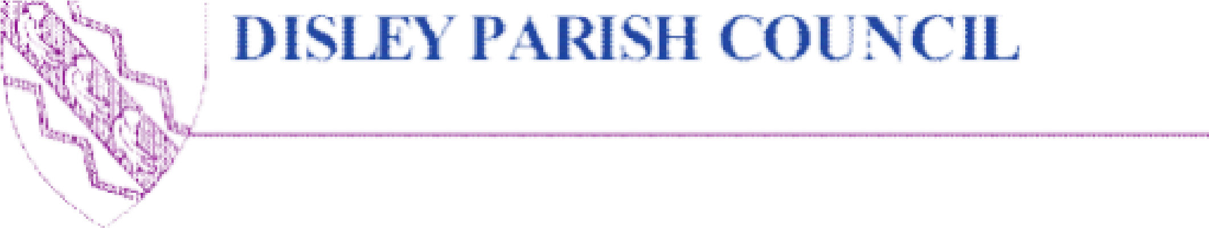
Disley Parish Council Meeting Minutes
9th April 2026 at 7pm at Disley Community Centre, SK12 2BB
Present
Cllrs: Adams, Bull, Windsor, Brinnand, Scale.

Officer in attendance
S. Allen
1 Member of the Public

- Apologies
Apologies were received from Cllr Pattison.

- Declarations of Interest
No disclosable pecuniary, personal or prejudicial interests were declared.

- The minutes of the meeting held on 12th March 2026 were APPROVED and SIGNED as a correct record.

- Public Participation
There were no comments received from members of the public.

Chair’s Report
The Acting Chair provided a verbal report:
- The village litter pick was highly successful even with the terrible weather. Over 30 participants collected a significant amount of waste. The Acting Chair thanked all who took part.
- The Rangers continue to carry out valuable work in the village centre, including clearing drains in the community centre car park. Works are approximately 80% complete and have made a noticeable improvement. The Acting Chair thanked all Disley Parish Council staff for their hard work.

- The Cheshire East Councillor’s report was RECEIVED. Cllr Adams provided a brief verbal update in regard to the planned gully clearing and jetting works, focusing on Jackson’s Edge Road and the crossroads with Buxton Road West. Works are scheduled for early Sunday morning, subject to vehicle access. A social media post and a leaflet drop will be completed to try and ensure cars are moved.

- The following consultations were CONSIDERED:
- Special Educational Needs and Disabilities (SEND) Surveys 2026. Closes 4th May 2026.
- Draft Rights of Way Improvement Plan 2026-36 Consultation. Closes 24th May 2026.
It was RESOLVED that:
- Cllr Brinnand will respond to the SEND consultation
- Cllr Windsor will respond to the Rights of Way consultation
ACTION: Cllr Brinnand to remind other SEND groups in regards to the SEND consultation.

8. Cllr Windsor gave a verbal update in regards to the Health and Wellbeing Project group. The minutes will be available at the next meeting. The Acting Chair thanked Cllr Windsor for the update.

- Finance
    - The payment approval list dated 23rd March 2026, was retrospectively APPROVED.
    - The re-investment of £70,000 of the balance of £80,022.39 of savings in a Cambridge & Counties Easy Access Account to a Cambridge & Counties fixed rate business bond was APPROVED.
    - The Council APPOINTED Cllr Windsor to check and sign the March bank reconciliation.

- The project group updates were NOTED.

- The grant application from St Mary’s Church was CONSIDERED. The discussion noted:
- The grant awarded in the 2025-6 financial year was £400
- The whole project cost is approximately £800
- Disley Parish Council budget constraints were acknowledged
It was RESOLVED to award a grant of £400 to St Mary’s Church.

- Disley Parish Council CONSIDERED and RESOLVED to re-adopt the Councillor Code of Conduct.

- Disley Parish Council CONSIDERED and RESOLVED to adopt the NALC Model Equality and Diversity Policy.

- The communication report provided by Cllr Brinnand was NOTED

- The current photocopier was NOTED as outdated and beyond its lease term. It was RESOLVED that the Clerk was authorised to obtain three quotes, select the best value option within an approved lease budget of approximately £2,500 + VAT, plus printing costs over five years and enter into a new lease agreement.

Reference | Address | Details | COMMENTS
26/0967/HOUS | 18 Jacksons Edge Road, Disley SK12 2JE | Excavation of raised ground level adjacent to dwelling to form new parking space with stone faced retaining walls. | Deadline 14/04/26  No objection subject to satisfactory resolution of holding objection from Network Rail.
DECISIONS
25/4549/HOUS | 6 Sherbrooke Road, Disley SK12 2ED | Two storey extension over existing rear extension and single storey rear extension. | Granted with 3 conditions
26/0360/HOUS | 5 Coppice Avenue, Disley SK12 2LS | Proposed front extension and canopy/roof to front with elevation treatments and side window. | Granted with 3 conditions
25/4549/HOUS | 6 Sherbrooke Road, Disley SK12 2ED | Two storey extension over existing rear extension and single storey rear extension. | Granted with 3 conditions

- Exclusion of Press & Public
RESOLVED: That, in accordance with section 1(2) of the Public Bodies (Admission to Meetings) Act 1960, the press and public be excluded from the meeting during consideration of the following item on the grounds that publicity would be prejudicial to the public interest due to the confidential nature of the business to be transacted.
There were no members of the press or public present at the meeting.

Part 2 - Co-option
- Em Johnson indicated her willingness to be a member of the Parish Council and provided a brief overview of her career and relevant skills.
The Acting Chair formally thanked Mrs Johnson for her interest in becoming a Disley Parish Councillor and PROPOSED that she be co-opted to the Council.
- RESOLVED: That Mrs Em Johnson be co-opted as a member of Disley Parish Council.
Mrs Johnson was welcomed to the Council.

19. Meeting closed at 20:05

