Name ______________________________________________ School _______________________________________ Contact Number ____________________________
“Get on Your Bike for the Disley Cycle Festival!”
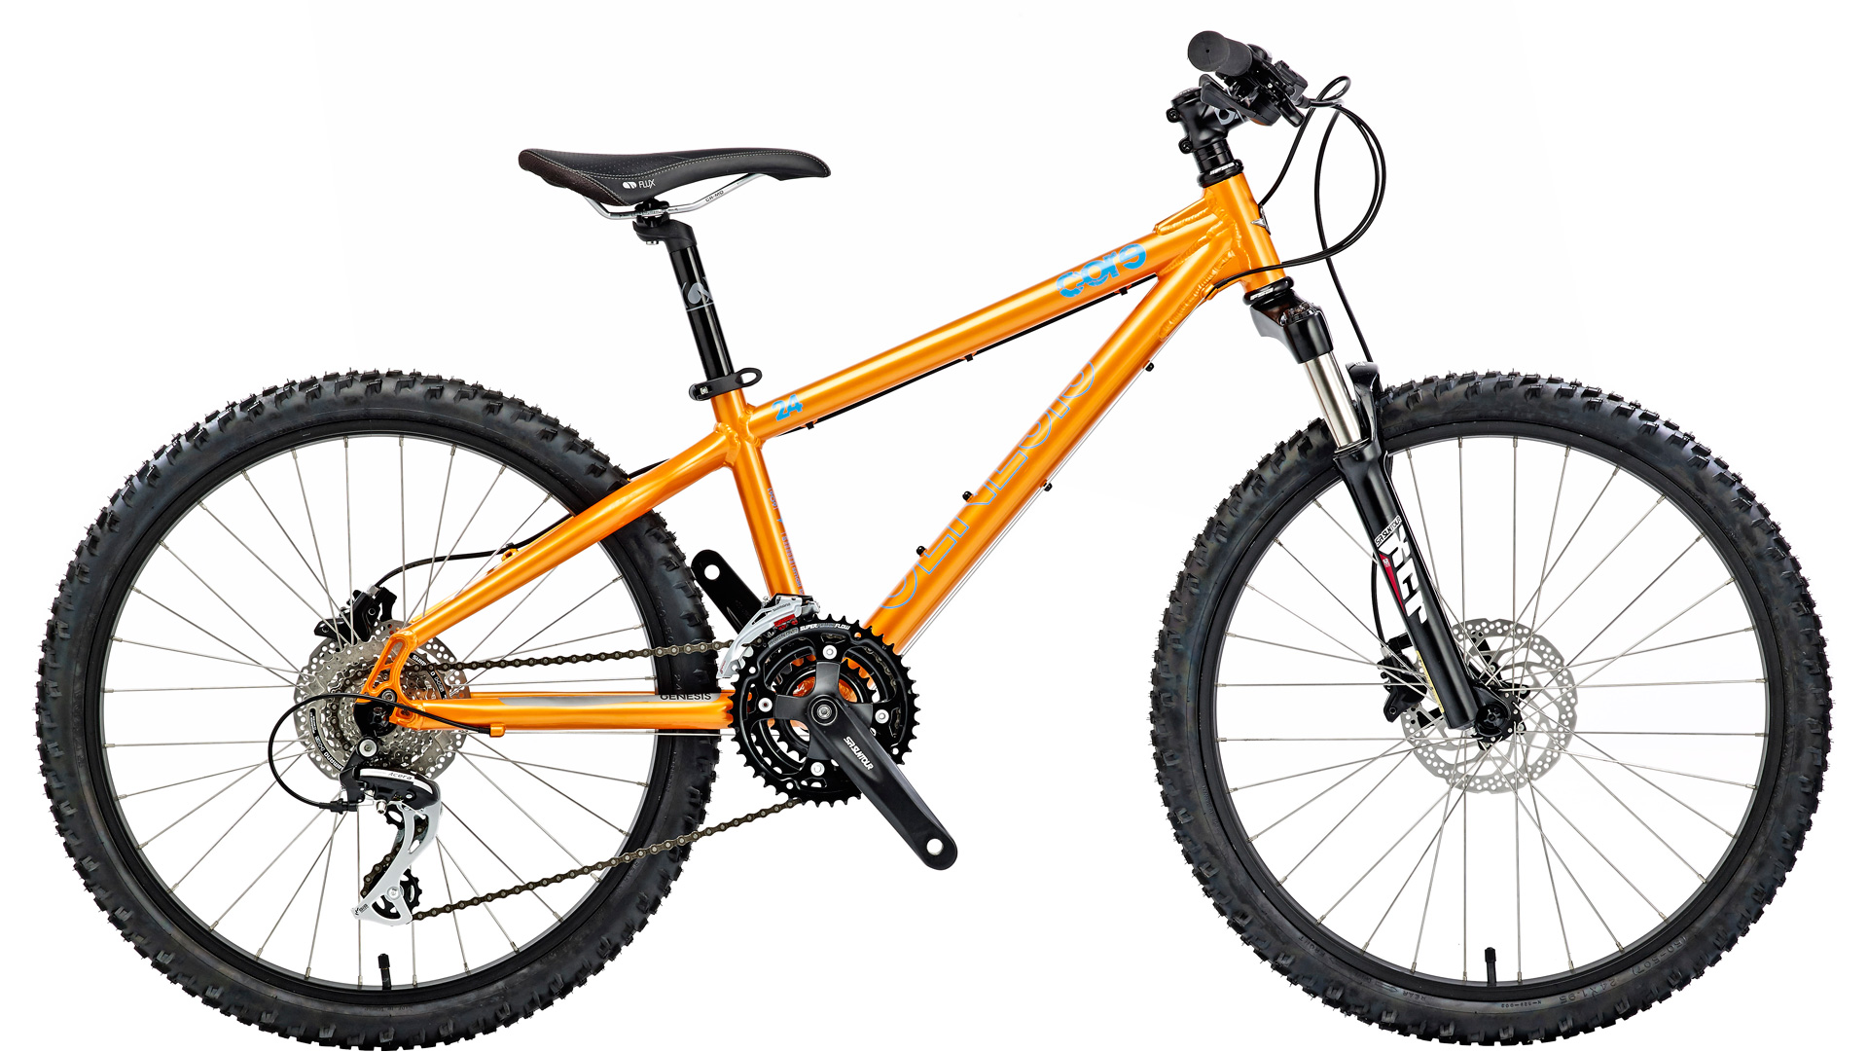
We are excited to announce Disley’s Annual Cycling Festival will take place on Saturday 19 September so put the date in your diary and get ready to polish the dust off those bicycles!
This is our third festival, which we hope will be bigger and better than ever. In addition to children’s bicycle activities & races, stalls, security marking, maintenance checks and attractions for all the family, we will be organising an off-road cycle route for older children and adults.
The prize for completing the course will be one of our very own Disley Cycling Festival T Shirts – and that is where we need you!
We are inviting pupils from local primary schools to get creative and create a logo, emblem or colourful design to represent the festival.
The winning design will be printed on the T shirts that will be presented to all cyclists who complete the route – so the winner will see their design being worn around the village! The winner will also receive a special prize.
You can use coloured pencils, paints or crayons. The winning design will definitely have a cycle theme, will almost fill the space and be bright and bold. You can enter as many times as you like.
All entries must arrive in Disley Parish Council offices by 4pm on Friday 21st August. Please use the space overleaf for your entry.
Don’t forget to tell us your name, school and contact number!
You can also scan & email designs to disley.pc@btconnect.com
Please fold your design into the centre & carefully seal with a small piece of sticky tape before returning your entry by Friday 21 August to:

Disley Cycling Festival Design Competition
c/o Disley Parish Council Offices
19 Buxton Old Road
Disley, Stockport
SK12 2BB

